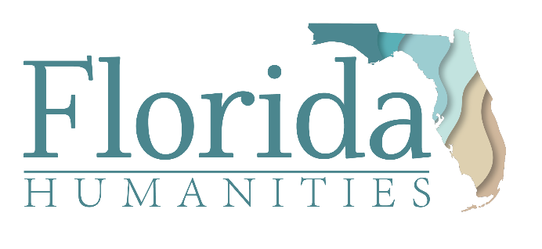

FOR IMMEDIATE RELEASE
Contacts:
Ben Gunter, Artistic Director, Theater with a Mission
Phone: 850-222-1214 | Cell: 850-800-6799
Email: bengunter@theaterwithamission.com
Lashonda Curry, Communications Director, Florida Humanities
Phone: 727-873-2011 | Cell: 813-447-1752
Email: lcurry@flahum.org
Theater with a Mission Receives
Florida Humanities “American Rescue Plan”
COVID Relief Funding
Tallahassee, Florida (November 15, 2021) — Florida Humanities, the statewide, nonprofit affiliate of the National Endowment for the Humanities (NEH), has awarded Theater with a Mission (TWAM) a $5500 grant for general operating costs to help recover from the economic impact of the COVID-19 pandemic.
Theater with a Mission will use these funds to retain three people whose services make essential contributions to TWAM’s mission of making Florida’s history come to life in vivid reenactments – dance historian Idy Codington, dramaturg Aaron Ellis, and videographer Jennifer Petuch. In addition, “American Rescue Plan” support will equip TWAM hire expert speakers from the Florida Humanities Speakers Bureau and open a Vimeo channel featuring lively encounters with Territorial Florida, leading up to Tallahassee turning 200 in 2024.
“Timing and targeting are perfect,” comments Artistic Director Ben Gunter. “We are deeply grateful to Florida Humanities, the National Endowment for the Humanities, and to Congress for understanding the damage that COVID has done to people whose gifts lie in bringing history to life. And we look forward to Floridians building better futures as we become smarter about our past.”
The NEH received $135 million from the American Rescue Plan (ARP) Act of 2021, which was approved by Congress this past spring. The state humanities councils, including Florida Humanities, each received a portion of the NEH award to support museums, archives, historic sites and other humanities-focused nonprofits. Theater with a Mission was one of 129 organizations in Florida awarded ARP funding totaling $1.88 million from Florida Humanities. The grants are intended to meet immediate operational needs in order for organizations to remain viable and maintain delivery of public humanities programming and resources in their communities. Florida Humanities received 188 applications for ARP funding, with nonprofits requesting the most funds for staffing and utilities.
These funds, said Florida Humanities Executive Director Dr. Nashid Madyun, provide a safety net for the organizations so they can focus on other priorities, such as fundraising and creating programming. “For smaller nonprofits, when bills are paid and staff are safe and intact, that type of alleviation is immeasurable,” he said. “Florida Humanities is honored to provide a lifeline to our state’s cultural and historic organizations, ensuring they continue to enrich their local communities, and the Sunshine State at large, for years to come.”

Funding for this grant was provided by Florida Humanities with funds from the National Endowment for the Humanities (NEH) as part of the American Rescue Plan (ARP) and NEH’s Sustaining the Humanities through the American Rescue Plan (SHARP) initiative. Any views, findings, conclusions or recommendations expressed in this announcement do not necessarily represent those of Florida Humanities or the National Endowment for the Humanities.
______________________________________________________________________

About Theater with a Mission (TWAM)

Theater with a Mission (TWAM) creates historical reenactments, speaker series, and festivals full of hands-on lecture-demonstrations to carry audiences across barriers of language, time, and space into face-to-face encounters with Florida’s past and history's great ideas.
To fulfil our mission, we:
- premiere new plays that dramatize first-person perspectives on historic milestones,
- translate plays written when Spain ruled Florida, then tour them in English spiced with 17th-century Spanish, complete with historically accurate costumes, songs and dances,
- create free festivals full of interactive experiences and scholarship, immersing people in Florida’s rich multicultural heritage.
About Florida Humanities
Florida Humanities, the statewide, nonprofit affiliate of the National Endowment for the Humanities, is dedicated to preserving, promoting, and sharing the history, literature, culture, and personal stories that offer Floridians a better understanding of themselves, their communities, and their state. Since 1973, Florida Humanities has awarded more than $16 million in support of statewide cultural resources and public programs strongly rooted in the humanities. These programs preserve Florida’s diverse history and heritage, promote civic engagement and community dialogue, and provide opportunities to reflect on the future of Florida. Learn more at www.FloridaHumanities.org.

